Modulation Using MATLAB
  - Communication Theory and Systems (CIE 337)
Aml Tarek | 202200126
Mohammad Mahmoud | 202200438
Youssef Allam | 202200286

Contents
2 Generation of Message Signals 2
3 Double Sideband-Quadrature Amplitude Modulation 2
3.1 Modulation 2
3.2 Coherent Demodulation 3
3.3 Phase Error in Demodulation 4
3.4 Frequency Error in Demodulation 5
4 Angle Modulation 5
4.1 Phase Modulation 5
4.2 Effect of Phase Modulation Constant 6
4.3 Frequency Modulation of $m2$ 7
4.4 Frequency Modulation of $m1$ 9

Generation of Message Signals
Throughout this project we used 2 signals $m_{1}\left(t\right),m_{2}\left(t\right)$. The first signal is a periodic sawtooth signal and the second is a periodic superposition of various rectangular functions. Figure 1 shows the 2 message signals for a time period of 2msec.
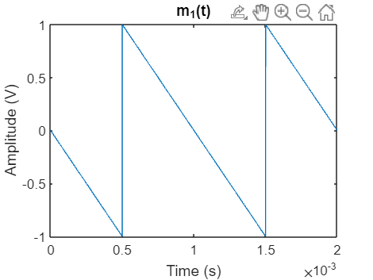  Figure 1(Message Signal 1) | 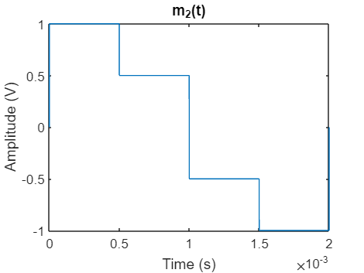  Figure 2(Message Signal 2)

Double Sideband-Quadrature Amplitude Modulation

Modulation
In this part we aimed to simulate Double Sideband Quadrature amplitude modulation (QAM) in which we transmit 2 separate messages using the same transmission bandwidth. This is accomplished using 2 orthogonal carrier signals which will be a cosine signal and a sine signal of the same frequency. The generated signal will be of the form
$$s\left(t\right)=A_{c}m_{1}\left(t\right)cos\left(2πf_{c}t\right)+A_{c}m_{2}\left(t\right)sin\left(2πf_{c}t\right)$$
In this case we choose $A_{c}=5,f_{c}=5KHz$. We generate both sinusoidal signals and perform the modulation by simply multiplying and plotting the modulated signal. Before we look at the modulated QAM signal we look at the modulation of each of the carrier signals with its respective message signal.
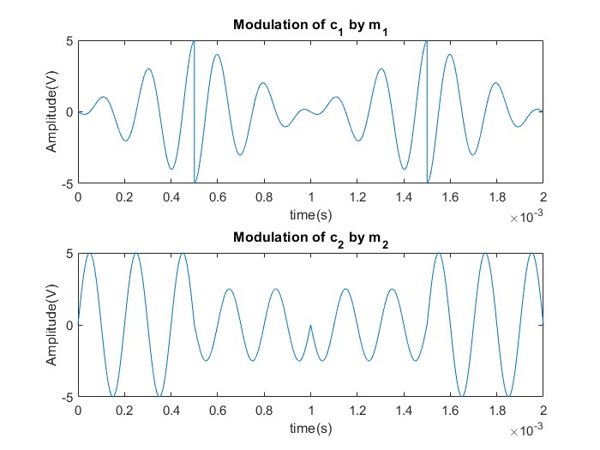
Figure 3(Modulation of m1 and m2 independently)
We notice that the sharp discontinuities in the first term due to the steep part of the sawtooth signal is reflected by discontinuity at the same time instances in the first graph. The discontinuity in the second message signal when it moves from positive to negative is reflected by a phase shift at t=1msec in the second graph. The QAM signal will be the sum of the 2 above signals.
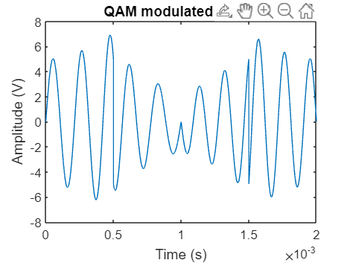
Figure 4(QAM Modulated Signal)

Coherent Demodulation
Next, we use a QAM receiver to demodulate the signal. The demodulation process will simply be multiplying the modulated signal once by the cosine signal and once by the sine signal to get $m_{1}$ and $m_{2}$ respectively. We also multiply by a proper gain factor of $2/A_{c}$ to get back the signal with the same magnitude. We used a low pass filter of cutoff frequency 2200Hz.
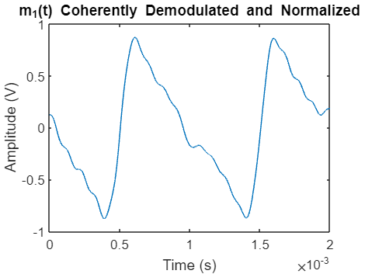  Figure 5(Received signal for message 1) | 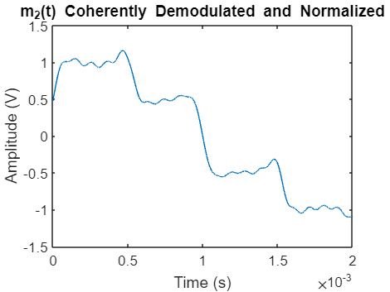  Figure 6(Received Signal for message 2)
We notice that the recovered signal is not identical to the original message signal. This is simply due to the nature of the signals. The square wave and triangular wave signals have infinite frequency components (i.e., their Fourier series consists of infinite terms). When we use a low pass filter to get rid of the higher frequency carrier components, we also lose a part of the original message’s spectrum. We also note that the rectangular wave is more distorted. This is mainly because the lower frequency terms of the triangular wave contribute more to the total power of the wave as compared to the lower frequency terms of the square wave. The selected cutoff frequency of 2200Hz was reached through trial and error since for such extreme signals with an infinite spectrum we cannot determine a specific cutoff frequency in which we fully recover the signal.

Phase Error in Demodulation
We next test the case where the carrier signal at the receiver suffers from a phase error such that the carrier signal at the receiver is shifted by $\frac{π}{3}$. The graphs below show the recovered signals for $m_{1},m_{2}$
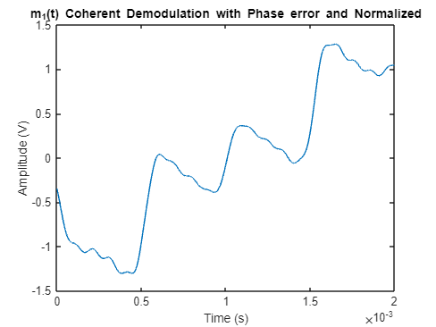 | 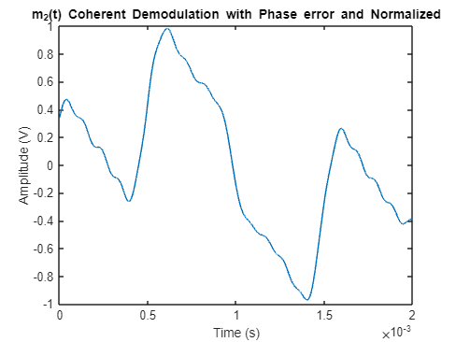
Figure 7(Received signal with phase error)
We notice in this case the co-channel interference between the 2 messages such that we see triangular pulses in the second message and almost rectangular pulses in the first message.

Frequency Error in Demodulation
We next add a frequency error instead of a phase error to the carrier signal at the receiver in which we make $f_{c}=1.01f_{c}$ which translates to a frequency error of 50Hz. The outputs for $m_{1},m_{2}$ are shown below.
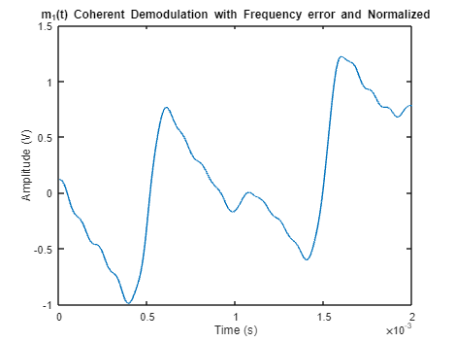 | 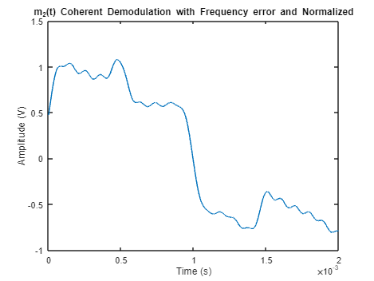
Figure 8(Received Signals with Frequency Error)
As one final note for the errors in the demodulation we look at the general formula for co-channel interference in which the recovered signal is given by
$$m_{1}'\left(t\right)=m_{1}\left(t\right)cos\left(∆ωt+δ\right)-m_{2}(t)sin\left(∆ωt+δ\right)$$
This explains the traces we see of $m_{2}$ in the recovered message for $m_{1}$ and vice versa.

Angle Modulation
In this section we will be using the same 2 message carriers used in the previous section.

Phase Modulation
In this part we will use phase modulation for different values for the phase modulation constant $k_{p}$ on the sawtooth message signal. We will use a carrier signal of amplitude 1V and frequency 10KHz. The modulated signal will be given by
$$s\left(t\right)=A_{c}cos\left(2πf_{c}t+k_{p}m_{1}\left(t\right)\right)$$
First we will plot it for $k_{p}=0.05$
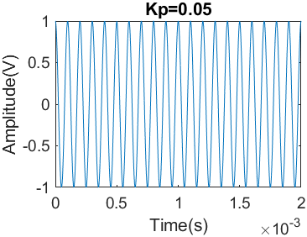
Figure 9(Phase Modulation of message signal 1)
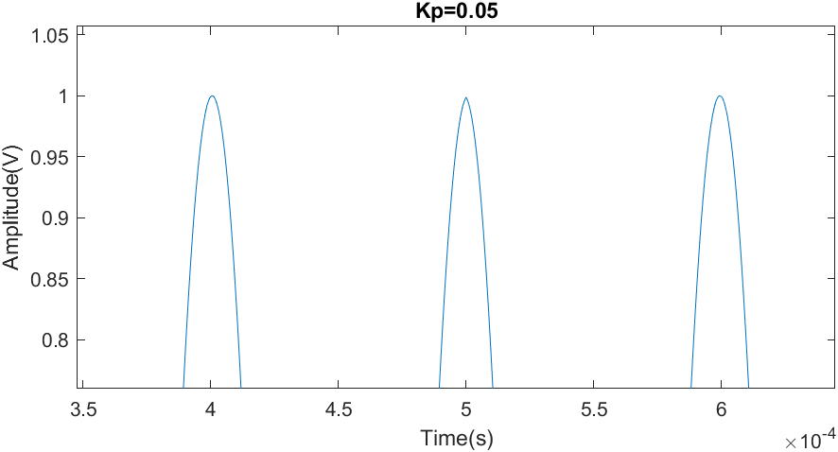
The frequency of the phase modulated wave is given by $ω=2πf_{c}+k_{p}\frac{dm_{1}\left(t\right)}{dt}$. The derivative of the message signal is a constant at all points except the points of discontinuity. At the points of discontinuity there will be a phase shift of $k_{p}m_{d}$ where $m_{d}$ is the amount of discontinuity. This gives us a phase shift of 0.1. By looking at the figure on the right we notice the abnormality at t=5msec which is the point of discontinuity in our message signal. We see that the wave is less smooth at that point than the peaks before and after as well as a bit thinner and does not reach a peak of exactly one. This is due to the phase shift caused by the discontinuity of the original message signal.
Figure 10(Phase shift at Point of Discontinuity in message 1)

Effect of Phase Modulation Constant
We will now observe the effect of the phase modulation constant on the modulated signal. Looking at the equation for frequency we notice that as the constant increases the magnitude of the change in frequency $∆f$ will also increase where $∆f=|k_{p}\frac{dm_{1}\left(t\right)}{dt}$|. In our case, as the modulation constant increases, the observed frequency will proportionately decrease since the slope is negative, however the phase shift caused at the points of discontinuity increase. This point is illustrated clearly in the figure below which shows the modulated signal for different values of $k_{p}$
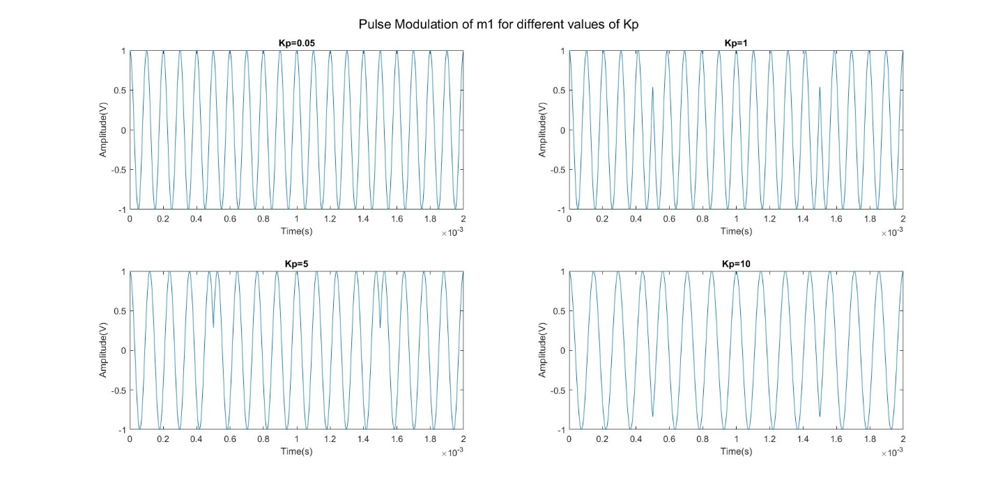
Figure 11(Comparison of Modulated Signal for Different Modulation Constants)

Frequency Modulation of $m_{2}$
Next we will frequency modulate the second (square wave) message signal. The frequency modulated signal is given by
$$s\left(t\right)=A_{c}cos\left(2πf_{c}t+k_{f}\int{m_{2}\left(t\right)}\right)$$
The frequency modulated signal is shown in the figure below.
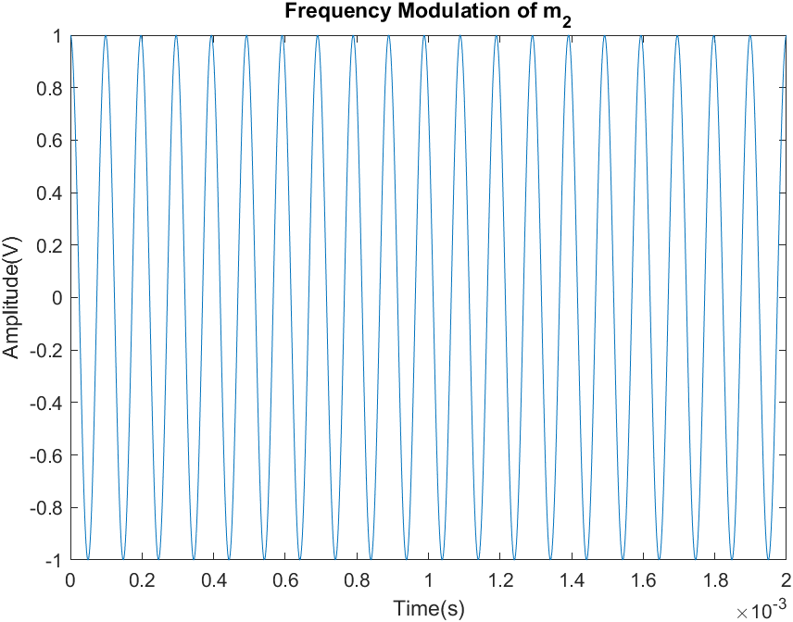
Figure 12(Frequency Modulation of Second Message Signal)
We will use the same carrier signal used in the previous section as well as a frequency modulation constant of 1000. The frequency in this case will be given by
$$ω=2πf_{c}+k_{f}m_{2}\left(t\right)$$
The value of $m_{2}\left(t\right)$ will fluctuate over the period reaching a maximum of 1 and -1. Thus the change in frequency $∆f$ will vary from 1000 to -1000. To ensure that the frequency varies properly we compare the time period at different points. For the time between 0.5 and 1 msec the frequency should be $2πf_{c}+0.5k_{f}$. For time between 1 and 1.5 it should be $2πf_{c}-0.5k_{f}$.The difference between them should be $k_{f}$ in radians/sec which is $\frac{1000}{2π}≈160$ in hertz. By comparing a period before and a period after 1msec as in the graph below.
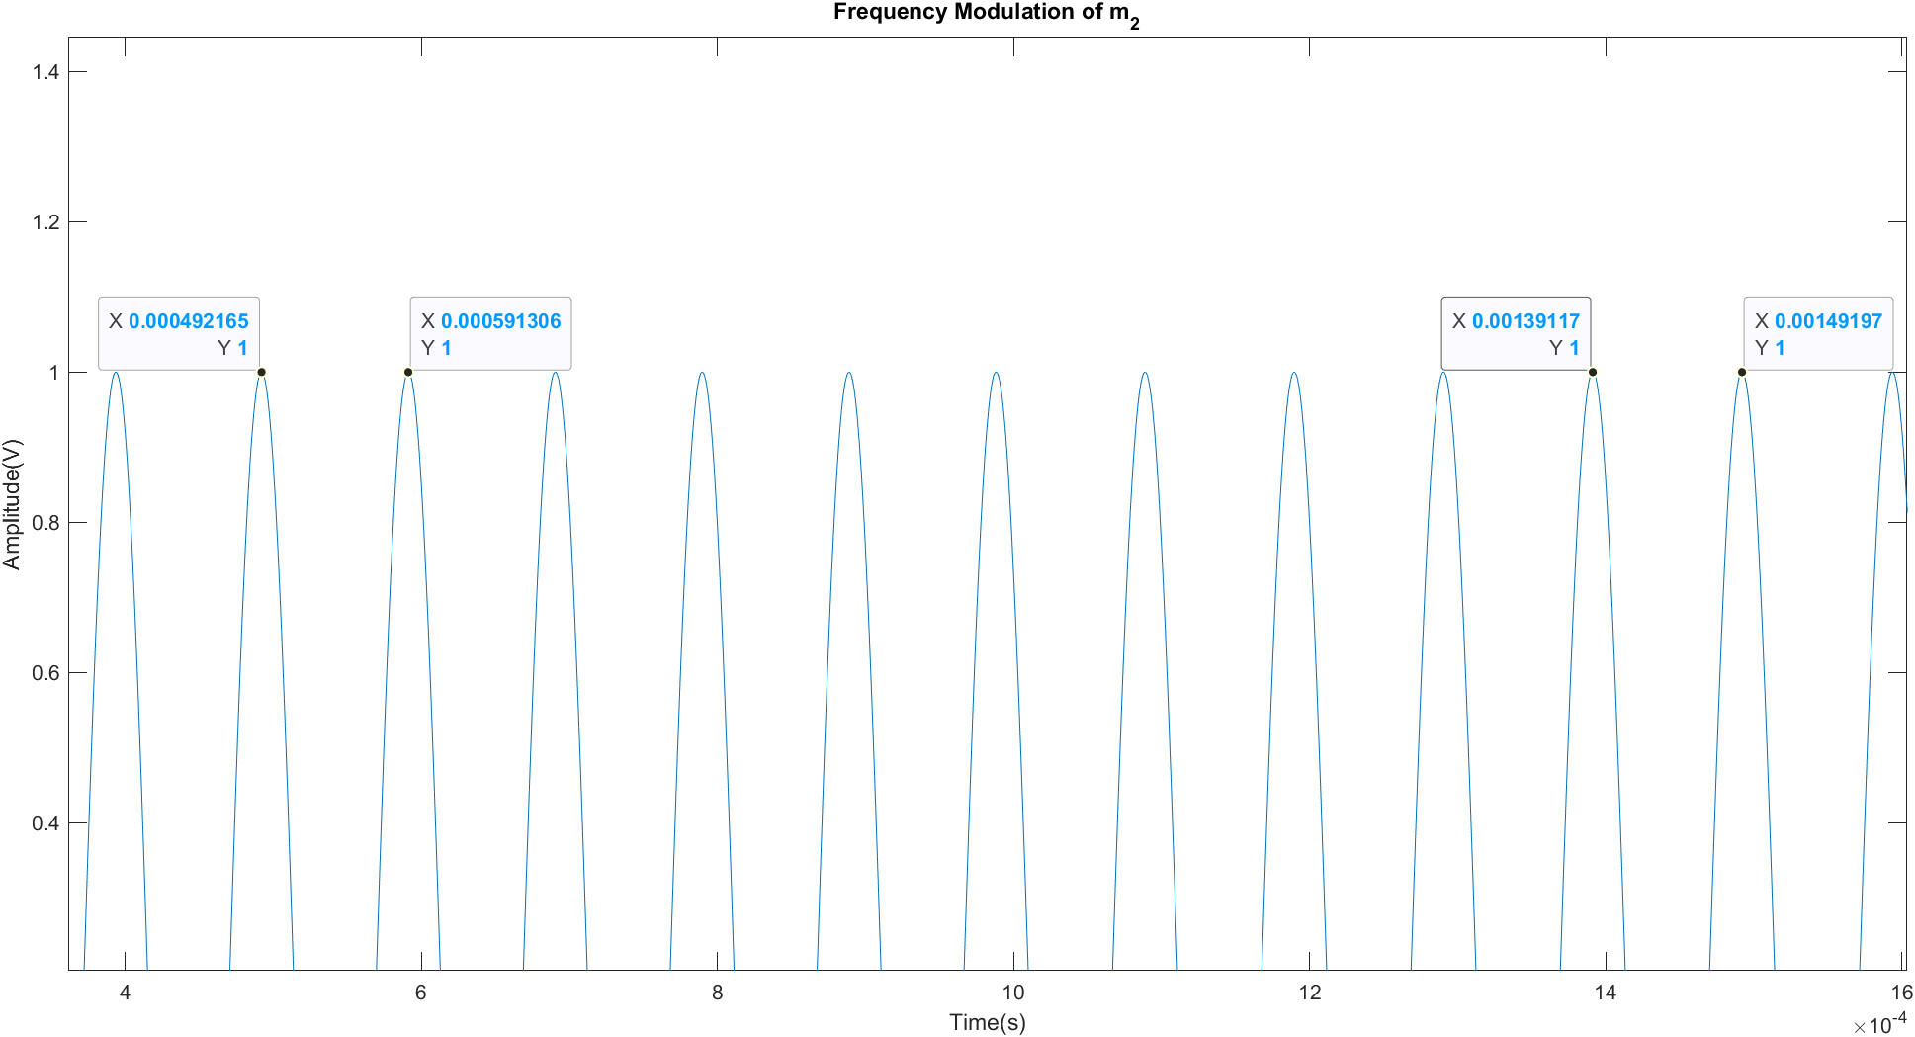
Figure 13(Numerical Comparison of Frequencies in Modulated Signal)
By calculating the period of each cycle then the frequency and then the absolute difference between the 2 frequencies we get a frequency difference of 166. This small difference between the theoretical and measured values is most likely a result of the precision limits. This shows that the frequency doesn’t remain constant and in fact varies with the message signal as we expect.

Frequency Modulation of $m_{1}$
We will perform the same analysis and simulation we did in the previous part using $m_{1}$. This time we will use a frequency modulation constant of 2000. The figure below shows the frequency modulated signal.
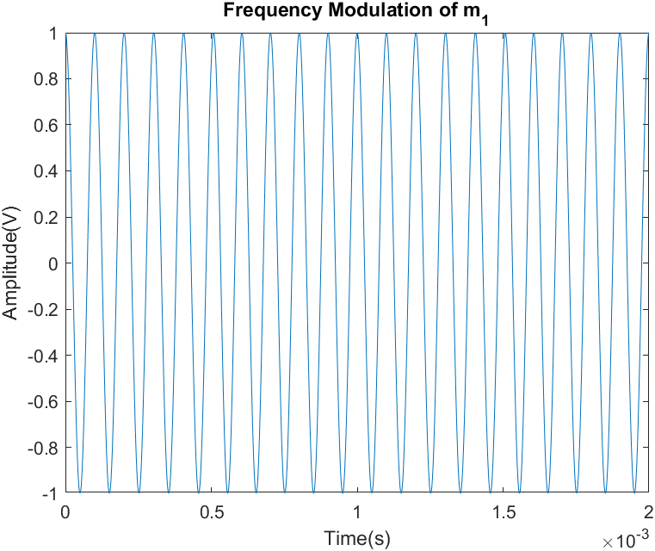
Figure 14(Frequency Modulation of First Message Signal)
The frequency in this signal will be continuously changing because $m_{1}$ is continuously changing unlike $m_{2}$ which was constant over a certain interval. We can still however show that the frequency varies in the same way we did in the previous section.
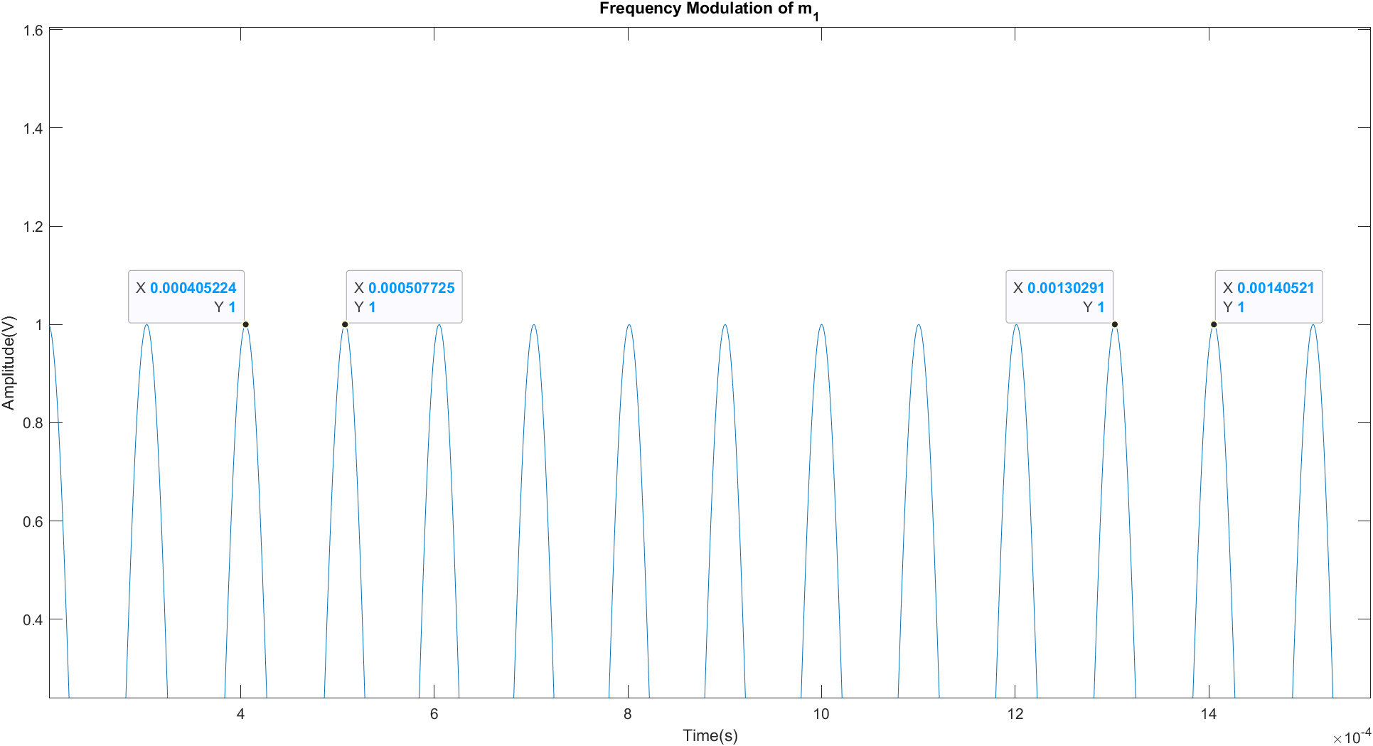
Figure 15(Numerical Comparison of Frequency Modulated Signal)
Performing the same analysis, we did in the previous section by calculating the period of each cycle then the frequency then the absolute difference we get a change in frequency equal to 20Hz between the 2 cycles.

